Day22
30th July 2025

Solid principles
Uml diagram - intro

Day 22 July 30 2025
Mohammed Taha Arsalain
mobarsal@amazon.com
Solid principles
Uml diagram - intro

Aggregation
Composition
Association
Hierarchy

Tight and loose coupling

Wild card lower and upper bounds

Code smells of SOLIDS
Task 1:

What is good code vs Bad code ..

11.35 to 11.40

Task 2:

BAD CODE vs GOOD CODE - ORAL

8 min 11.41 to 11.48

Task 3:
| Good Code | Bad Code |
| ------------------------------------- | ------------------------------- |
| Readable //Cleaner code | Confusing and Hard to read/underatsand |
| eassy to maintain || Hard to maintain
| Reausble | | Tightly coupled // Hard to reuse
| Easy to test | Difficult or impossible to test |
| Easy to change | Breaks when touched |
| Follows principles (SOLID, DRY, KISS) | Does not follow the principles|

Task 3:

What do you understand by databinding?

Data binding is the process of connecting data (like variables, objects, or database values) to something that displays or uses it—typically a user interface (UI).

When the data changes, the UI updates automatically.
Optionally, when the user changes the UI, the data is updated too.

Task 4:

What do you know about continuous development

Continuous Development is a modern software engineering practice where software is developed, tested, and delivered in small, frequent increments to accelerate release cycles and improve quality.

It’s often used interchangeably or together with concepts like Continuous Integration (CI) and Continuous Delivery/Deployment (CD), forming part of the DevOps pipeline.

Continuous Development is about making software development a smooth, automated, and continuous process—so teams can deliver reliable software faster and more frequently.

11.53 to 11.57

Task 5:

What are the conditions for polymorphism?

Condition | Needed For | Why It Matters
Inheritance / Interface | Runtime | Allows object substitution
Overriding | Runtime | Enables behavior change
Overloading | Compile-time | Supports multiple versions of a method
Late Binding | Runtime | Enables method resolution at runtime
Common Interface | Both | Unifies access to different implementations

Tight and loose coupling

Wild card lower and upper bounds

Today’s

Code smells of SOLIDS

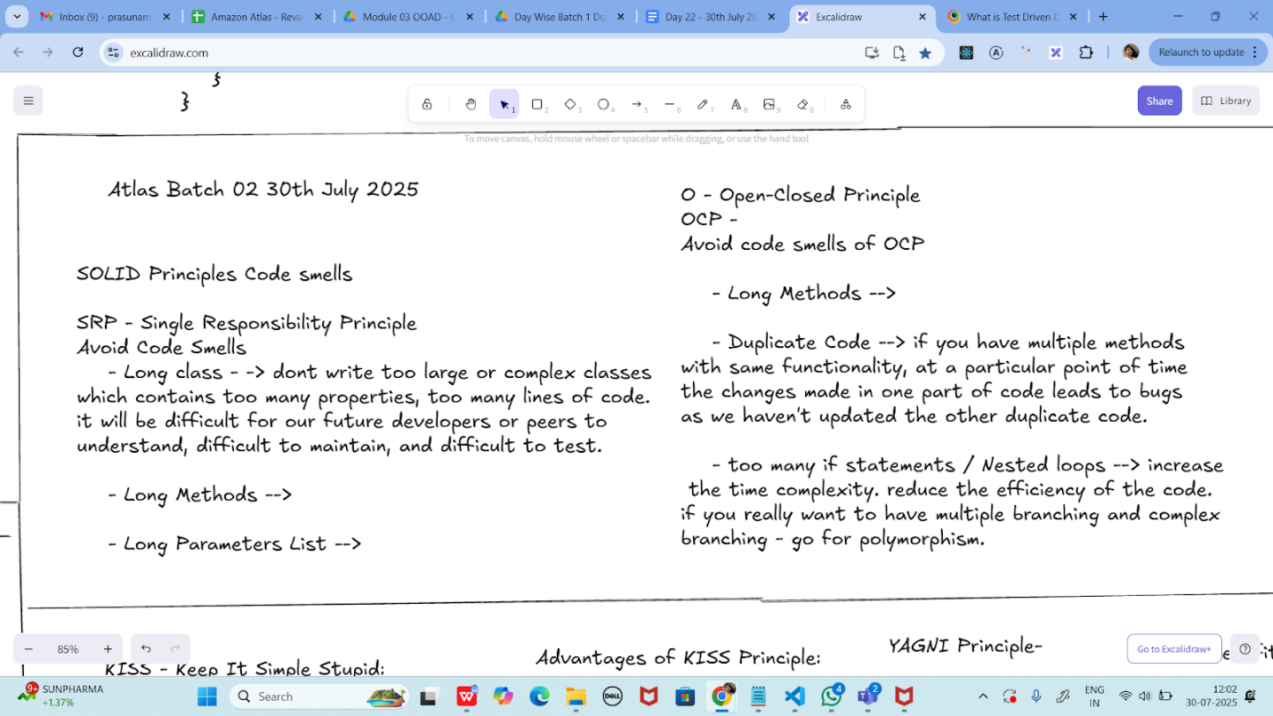

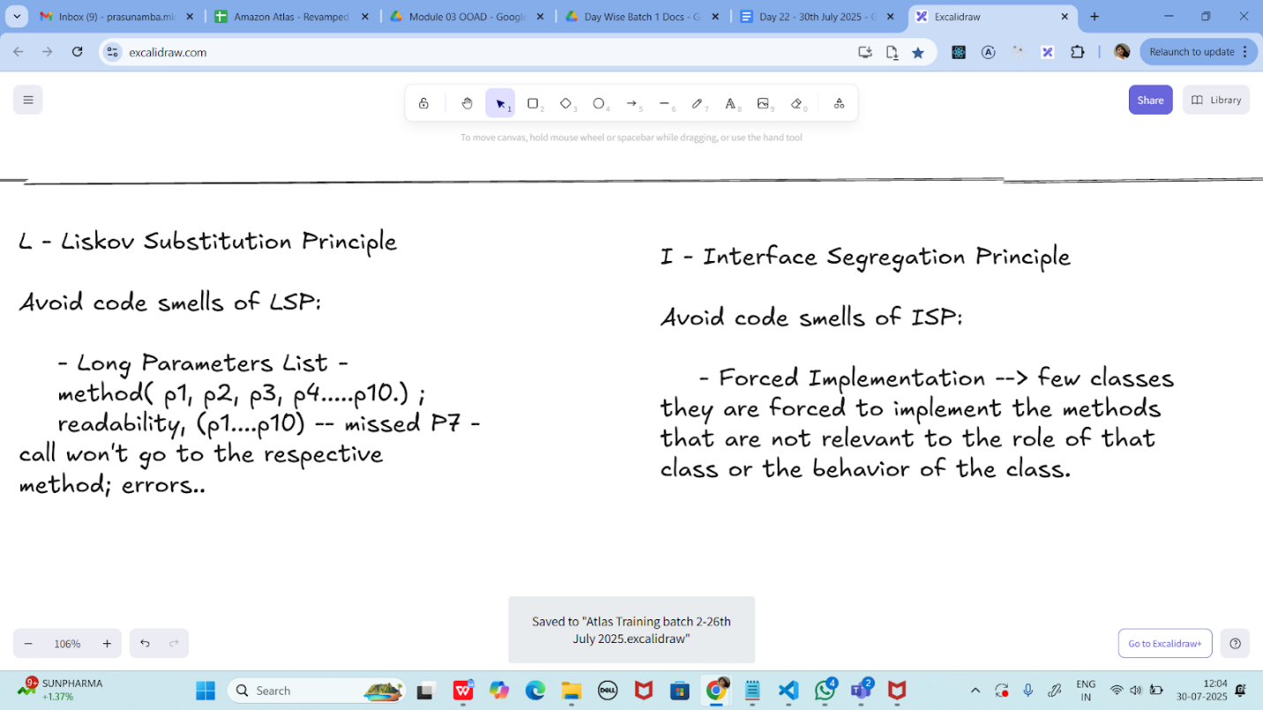

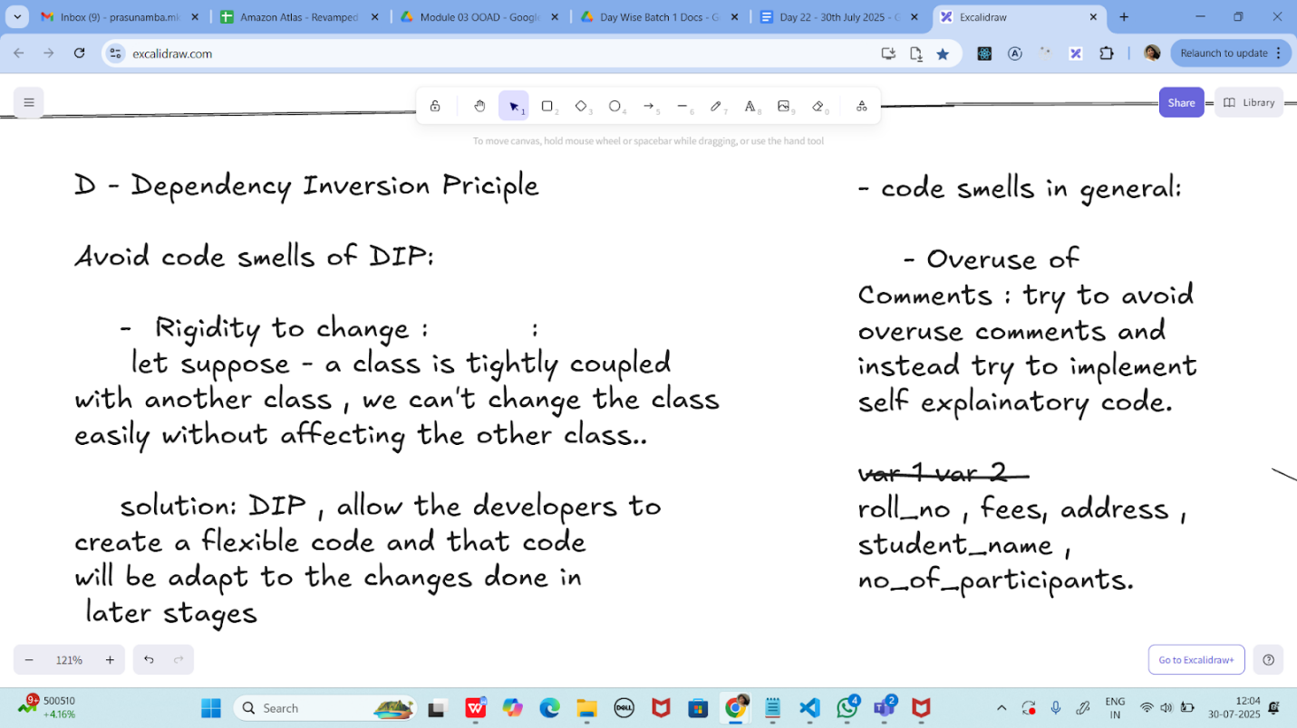

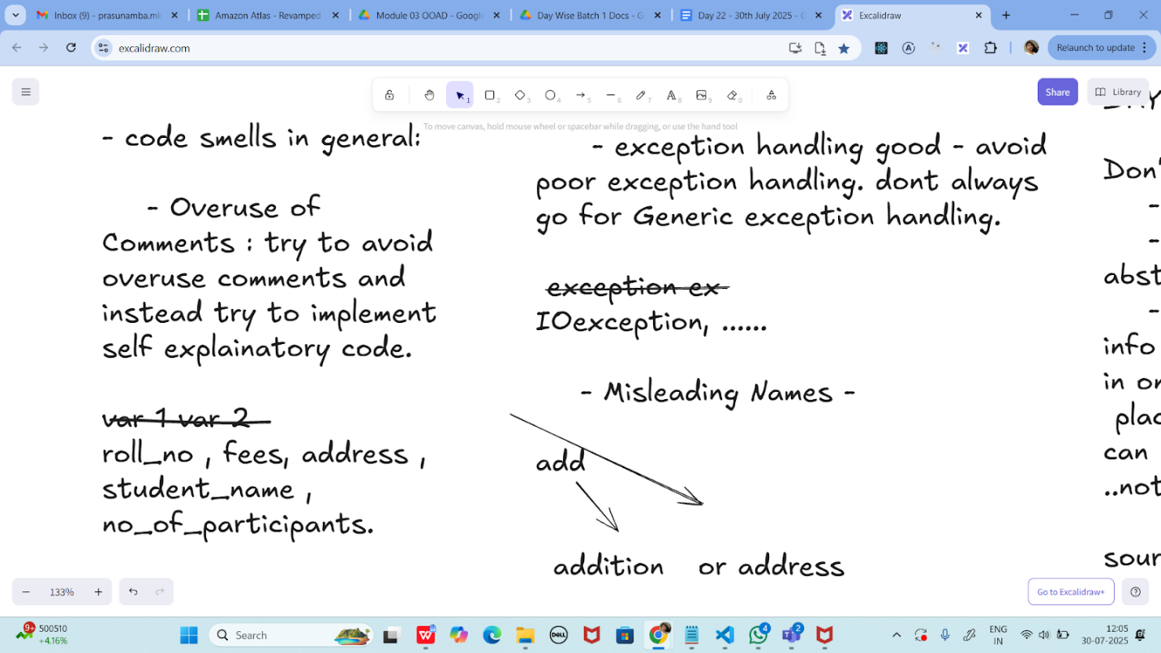

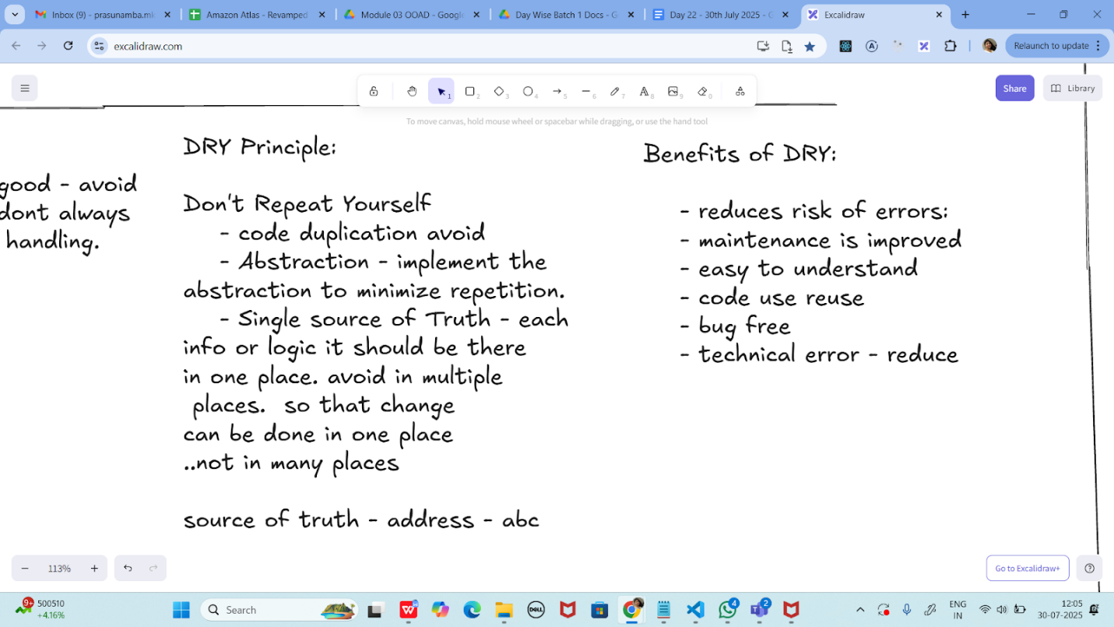

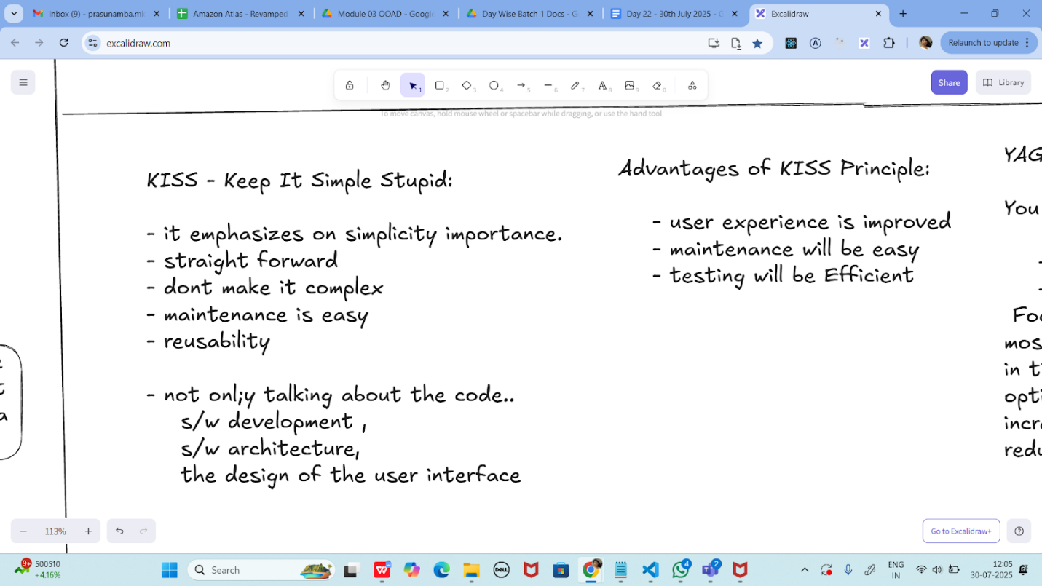

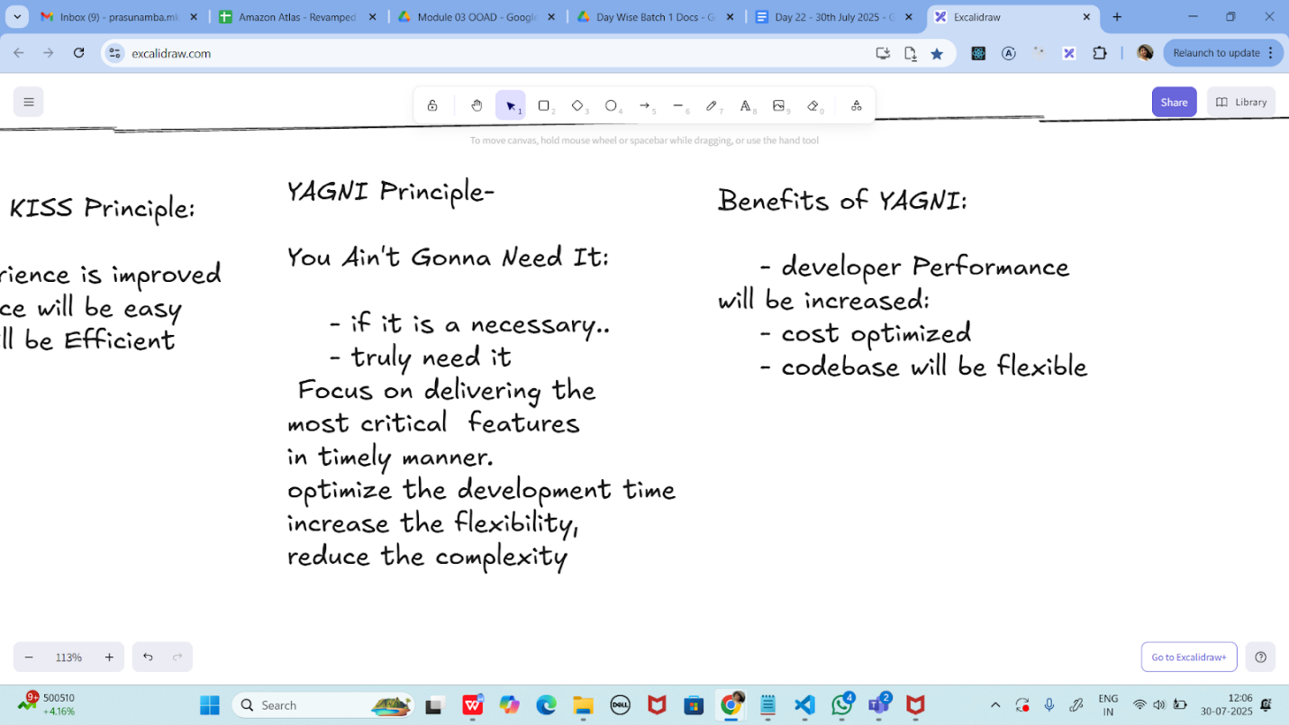

Task 1:

What is good code vs Bad code ..

11.35 to 11.40

Task 2:

GOOD CODE vs BAD CODE - ORAL

8 min 11.41 to 11.48 done - 11.53 to 12.02

Task 3:

What do you understand by databinding?

11.49 to 11.52

Task 4:

What do you know about continuous development

11.53 to 11.57

Task 5:

What are the conditions for polymorphism?

11.58 to 12.02

JUNIT code 1:

By Sudipto from chat window
import org.junit.jupiter.api.Test;
import static org.junit.Assert.assertEquals;
public class JunitTest01 {
String message = "hello all How are you";
@Test
void testMsg() {
System.out.println("asserting the Test case ");
assertEquals("hello all How are you", message);
}
}

Pom.xml

<project xmlns="http://maven.apache.org/POM/4.0.0"
xmlns:xsi="http://www.w3.org/2001/XMLSchema-instance"
xsi:schemaLocation="http://maven.apache.org/POM/4.0.0 http://maven.apache.org/xsd/maven-4.0.0.xsd">
<modelVersion>4.0.0</modelVersion>

<groupId>org.example</groupId>
<artifactId>Test01</artifactId>
<version>1.0-SNAPSHOT</version>

<dependencies>
<dependency>
<groupId>junit</groupId>
<artifactId>junit</artifactId>
<version>4.13.2</version>
</dependency>
<dependency>
<groupId>junit</groupId>
<artifactId>junit</artifactId>
<version>RELEASE</version>
<scope>test</scope>
</dependency>
<dependency>
<groupId>org.junit.jupiter</groupId>
<artifactId>junit-jupiter</artifactId>
<version>RELEASE</version>
<scope>test</scope>
</dependency>

</dependencies>
<properties>
<maven.compiler.source>21</maven.compiler.source>
<maven.compiler.target>21</maven.compiler.target>
<project.build.sourceEncoding>UTF-8</project.build.sourceEncoding>
</properties>

</project>

Task 07:

import org.junit.jupiter.api.Test;
import org.junit.jupiter.api.Tags;
import org.junit.jupiter.api.Assertions.assertEquals;
class TestCase02 {
@Test
@Tags("firstPriority")
void testMethod01() {

}

@Test
@Tag("firstPriority")
void runTestcase02() {

}
@Tags("fastTag")
void testMethod03() {

}

@Test
@Tag("slowTag")
void runTestcase04() {

}
}

Pom .xml by sayad:

<project xmlns="http://maven.apache.org/POM/4.0.0"
xmlns:xsi="http://www.w3.org/2001/XMLSchema-instance"
xsi:schemaLocation="http://maven.apache.org/POM/4.0.0 https://maven.apache.org/xsd/maven-4.0.0.xsd">

<modelVersion>4.0.0</modelVersion>

<groupId>com.example</groupId>
<artifactId>junit5demo</artifactId>
<version>0.0.1-SNAPSHOT</version>

<dependencies>
<dependency>
<groupId>org.junit.jupiter</groupId>
<artifactId>junit-jupiter</artifactId>
<version>5.10.0</version>
<scope>test</scope>
</dependency>
</dependencies>
<build>
<plugins>
<plugin>
<groupId>org.apache.maven.plugins</groupId>
<artifactId>maven-surefire-plugin</artifactId>
<version>3.1.2</version>
<configuration>
<includeTags>firstPriority,fastTag</includeTags>
<excludeTags>slowTag</excludeTags>
</configuration>
</plugin>
</plugins>
</build>
</project>

Task 08:

Write a test case for the below java file

public class Junit4Test {
public int compare(int n1, int n2) {
if (n1 > n2) return 1;
return -1;
}
}

Test case for your ref

public class Junit4TestCases {
@Test
public void compare() {
Junit4Test obj = new Junit4Test();
int value = obj.compare(20, 10);
Assertions.assertEquals(10, value);
}
}

Task 09:
Write test case for below code

public int compare(int n1, int n2) {
if (n1 > n2) return 1;
else if (n1 < n2) return -1;
return 0;
}

Info BOx

https://excalidraw.com/#json=_Cup10oNwNyB6wT2cbCXc,y88IaceH_ptz9HkLCpIJrg

Search for Altas Batch 02 30th july 2025

Plz refer Best Programming Practices - Doc 08 in Docs to study

Updated link @ 13.18

https://excalidraw.com/#json=6K0nAd3ha75fLzBDxBE5I,TlSFP1YMfMtAEKqunU0VdQ

JUnit dependencies:
Link

https://junit.org/junit4/dependency-info.html

<dependencies>
<dependency>
<groupId>ai.wanaku.sdk</groupId>
<artifactId>capabilities-common</artifactId>
</dependency>
</dependencies>

